Syeda Reeha Quasar

14114802719

3C7

Experiment - 10

Switching Theory and Logic Design (STLD)

Aim

To realize Multiplexer and Demultiplexer using only NAND gates.

# **EXPERIMENT - 10**

## **AIM:**

To realize Multiplexer and Demultiplexer using only NAND gates.

## **Hardware and Software Apparatus Required**

Hardware:

Breadboard, IC 7400 (NAND), LEDs, 5V power supply, connecting wires.

Software Simulation:

The schematic models of the desired circuits will be stimulated on MULTISIM (Free Software), easily accessible at [www.multisim.com](http://www.multisim.com).

Components used – Source (Clock Voltage), Passive elements (resistor), Digital components (AND, OR, NAND, NOR, XOR, XNOR, Inverter), Probe for Analysis and annotation (Digital), Schematic connectors (Ground)

## **Theory:**

Multiplexers are very useful components in digital systems. They transfer a large number of information units over a smaller number of channels, (usually one channel) under the control of selection signals. Multiplexer means many to one. A multiplexer is a circuit with many inputs but only one output. By using control signals (select lines) we can select any input to the output. Multiplexer is also called as data selector because the output bit depends on the input data bit that is selected. The general multiplexer circuit has 2n input signals, n control/select signals and 1 output signal.

De-multiplexers perform the opposite function of multiplexers. They transfer a small number of information units (usually one unit) over a larger number of channels under the control of selection signals. The general de-multiplexer circuit has 1 input signal, n control/select signals and 2n output signals. De-multiplexer circuit can also be realized using a decoder circuit with enable.

**REALIZATION OF 2:1 MUX** 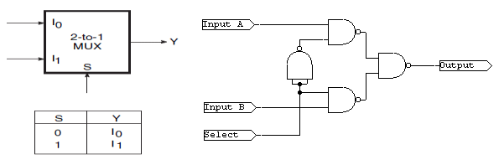

Fig 6.1 Truth Table and circuit implementation of 2:1 mux

**REALIZATION OF 1:2 DEMUX**

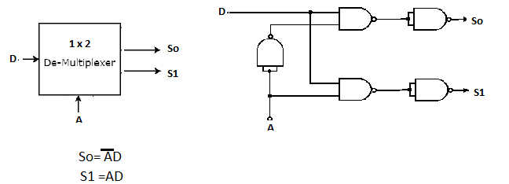

Fig 6.2 Logic Diagram and Circuit of 1:2 DMUX

## **Procedure:**

1. Check all the components for their working.
2. Insert the appropriate IC into the IC base.
3. Make connections as shown in the circuit diagram.
4. Verify the results and observe the outputs.

Multisim:

1. Click on the ‘Create Circuit’ option on the top right corner of the profile in NI
2. Multisim webpage.
3. The schematic representation opens in a new tab.
4. Place three ‘Ground’ Schematic connector on the screen.
5. Place the logic gates from the digital section on the board, as per the required circuit diagram for MUX and DEMUX circuits.
6. Now, add clock voltages to the input of the logic gate and connect them with the help of Ground present in ‘Schematic Connectors’.
7. Change the frequency of clock voltages e.g V1(say=5kHz) and V2(say=3kHz) etc.
8. Connect a resistor to the output of the logic gate and then, Ground it with the help of Ground Schematic Connector.
9. Connect the components with connecting wires.
10. Add digital probes to both input and output connections.
11. Set the display to ‘Transient’ from Interactive and press the ‘Start
12. Simulation’ button.
13. Note the graph

## **PRECAUTIONS:**

1. All ICs should be checked before starting the experiment.
2. All the connection should be tight.
3. Always connect ground first and then the supply.
4. Switch off the power supply after completion of the experiment.

## **RESULT:**

Multiplexer and Demultiplexer have been studied and their truth table has been verified.

**Circuits and Output waveform**

**2 X 1 MUX**

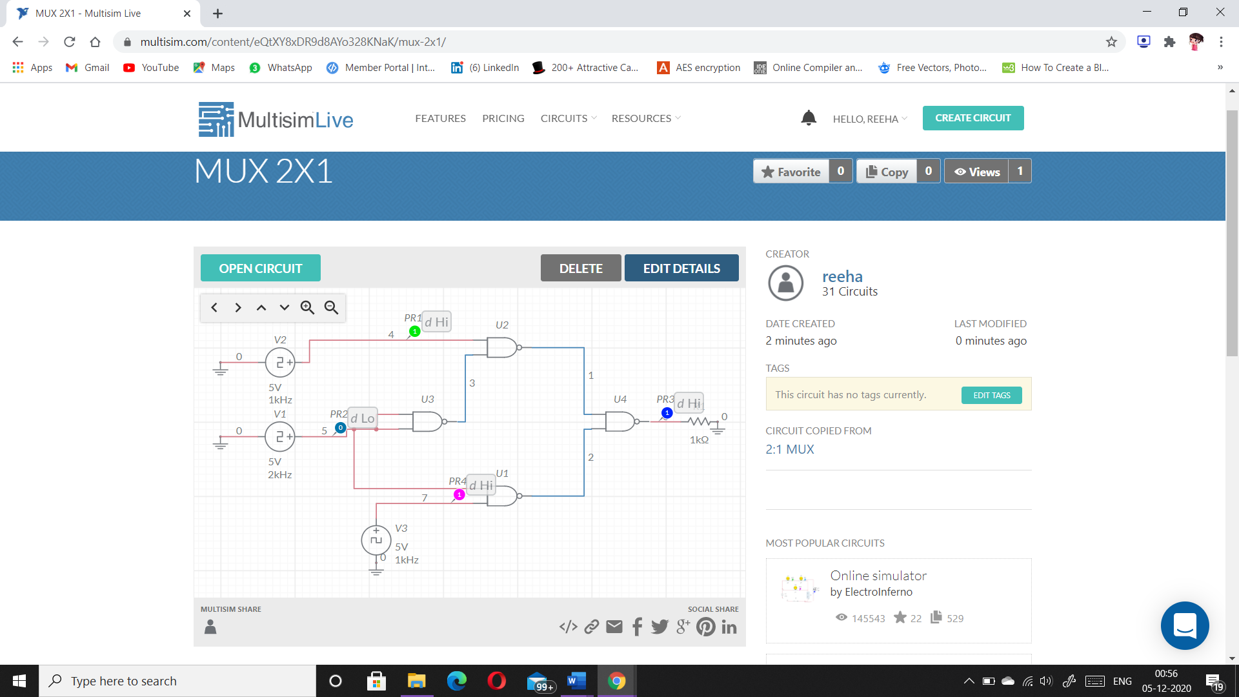

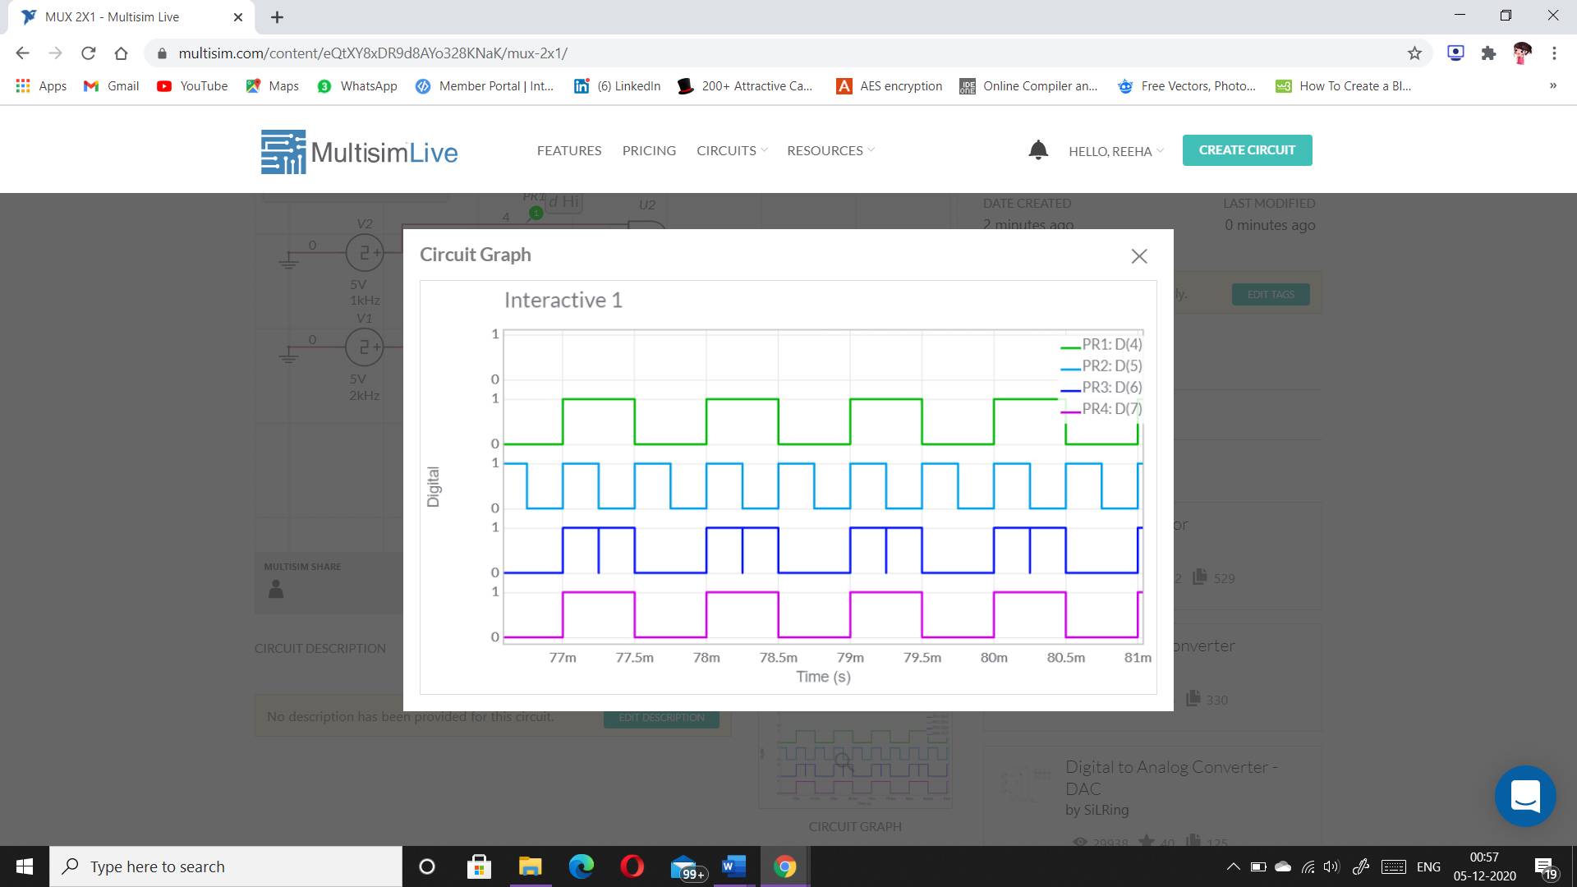

**1 X 2 DEMUX**

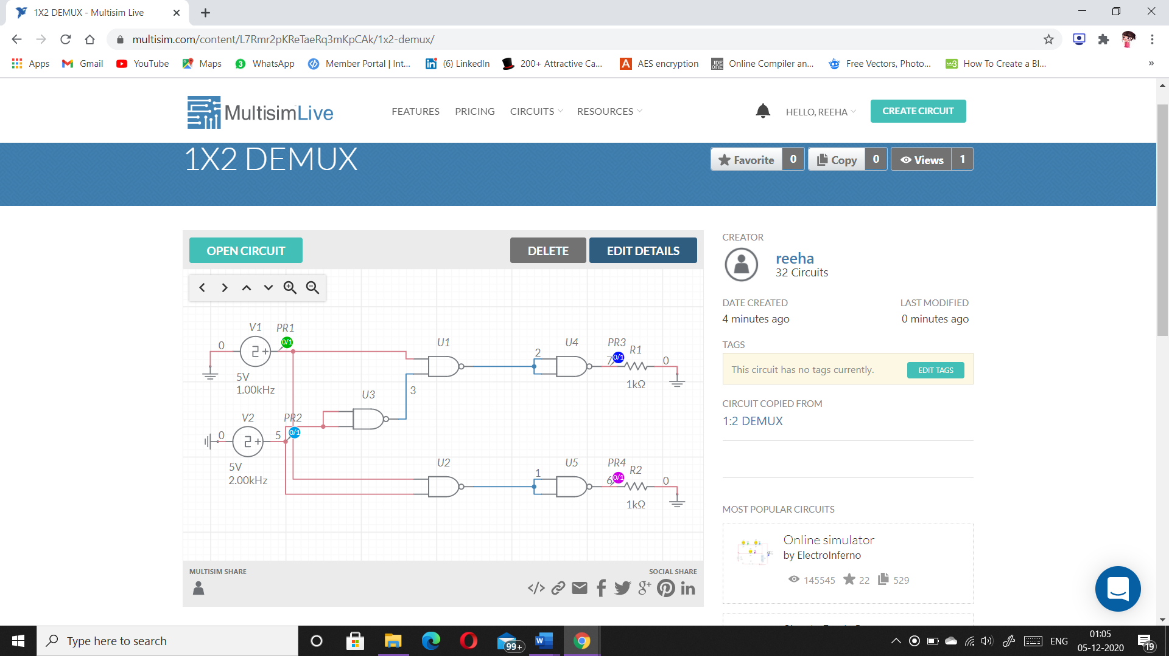

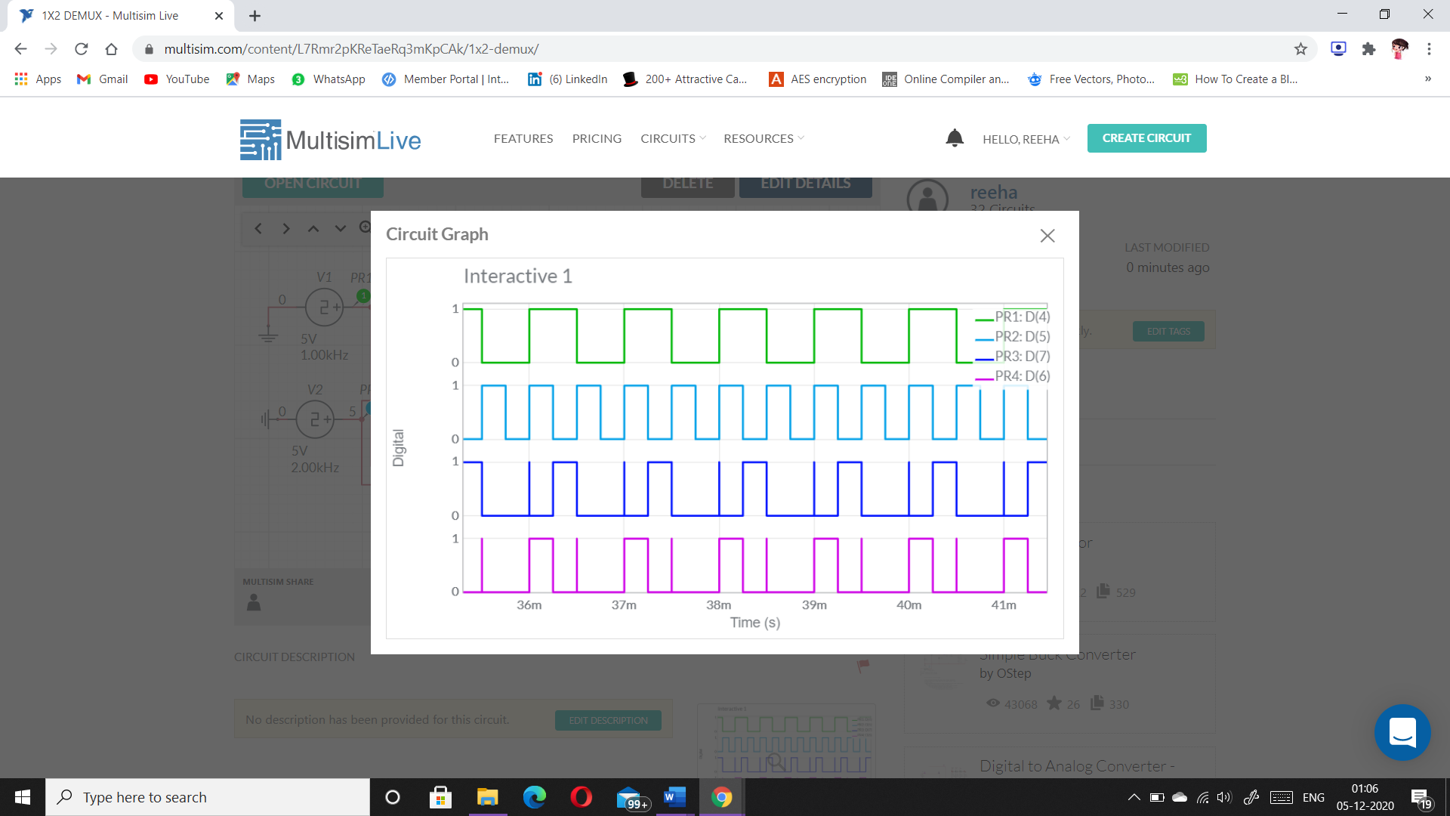

# **VIVA-VOCE QUESTIONS:**

1. **What is multiplexer?**

Ans.

Multiplexer means many into one. A multiplexer is a circuit used to select and route any one of the several input signals to a signal output. An simple example of an non electronic circuit of a multiplexer is a single pole multiposition switch.

1. **What is difference between decoder and demultiplexer?**

Ans.

|  |  |  |  |
| --- | --- | --- | --- |
| S.NO. | COMPARISON | DECODER | DEMULTIPLEXER |
| 1. | Basic | These are Logic circuit which decodes an encrypted input stream from one to another format. | It is a Combination circuit which routes a single input signal to one of several output signals. |
| 2. | Input/Output | n number of input lines and 2n number of output lines. | n number of select lines and 2n number of output lines. |
| 3. | Inverse of | Encoder. | Multiplexer. |
| 4. | Application | In Detection of bits, data encoding. | In Distribution of the data, switching. |
| 5. | Use | It is used for changing the format of the instruction in the machine specific language. | It is used as a routing device to route the data coming from one signal into multiple signals. |
| 6. | Select Lines | Not contains. | Contains. |
| 7. | Implementation | Majorly implemented in the networking application. | Employed in data-intensive applications where data need to be changed into another form. |

1. **Implement a AND gate with multiplexers.**

Ans.

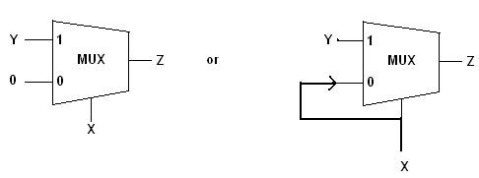

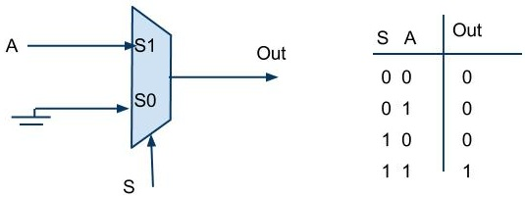

1. **How many 2x1 mux required to make 8x1 mux?**

Ans.

Seven 2X1 MUX are required.

